**Project Proposal**

MOSIME:AI-Driven Urban Mobility



Proposed by

Dereck Lam Hon Wah

Joomun Muddathir Ibney Noorani

Lakshit Sharma

Annu Lekisha Radha

Haardik Gautam

Submission Date: 10/10/2023

Table of Content

**Introduction 3**

**Problem Analysis 3**

**Proposed Solution 4**

Existing Solutions 4

**Business Intelligence in Project Design 5**

Phase 1 Data Collection, Analysis and Integration 6

Phase 2 STLS & ARPM 7

Smart Traffic Light System (STLS) 7

Accident Risk Prediction Model (APRM) 8

Phase 3 Mobile App Integration 8

**Human Centricity 9**

MOSIME: Co-existence 9

**Business Sustainability 10**

**Ethics and Governance 11**

**Reference List 12**

# Introduction

The urban landscape is evolving, and with it, the challenges of transportation. MOSIME, our AI-Driven Urban Mobility project, seeks to harness the capabilities of generative AI to address these challenges, ensuring safer, efficient, and sustainable city commutes.

# Problem Analysis

According to research, we noted that at end of December 2022, some 648,176 vehicles were registered at the National Land Transport Authority (NTA), compared to 622,988 at the end of December 2021, i.e. an increase of 25,188 or +4.0%. Some 31,734 vehicles joined the fleet, whilst 6,546 were put out of circulation during the year.

As at end of June 2023, some 661,553 vehicles were registered at the NTA, compared to 648,176 as at end of December 2022, i.e. an increase of 13,377(+2.1%).

The number of road accidents registered during the first semester of 2023 was 17,038, that is, 0.5% higher than the figure of 16,956 for the first semester of 2022.  
  
The challenge can be broken down into 5 sections:

1. **Traffic Congestion and inefficiencies**

Worldwide cities are witnessing an unprecedented increase in vehicular traffic, leading to traffic bottlenecks, longer commute times, increased fuel consumption and heightened stress levels among drivers.

1. **Road Safety Concerns**

Factors such as speeding, not wearing seat belts and helmets and distracted driving contribute to accidents and road mishaps. Moreover, the lack of real-time accident risk prediction systems means drivers aren't always aware of potential hazards.

1. **Inefficient Traffic and Public Transport Route Management Systems**

Traditional traffic light systems operate on fixed timers, irrespective of the traffic volume. leading to unnecessary waiting times at intersections. Conventional public transport systems do not optimise their routes based on real-time traffic data, leading to longer travel times for passengers and deterring its use. These result in congestion.

1. **Lack of Driver's Safety Features in Current Mobile Apps**

Most navigation apps focus primarily on route guidance, with little to no emphasis on the driver's safety.

1. **Low Public Awareness and Adoption**

The public might not be aware of available advanced mobility solutions or hesitant to adopt them due to lack of understanding or trust in this technology.

# Proposed Solution

To address the challenge, MOSIME will be rolled out in a structured three-phase process. Each phase is designed to tackle specific facets of the problem, ensuring an approach to a safer, efficient, and sustainable urban transportation system.

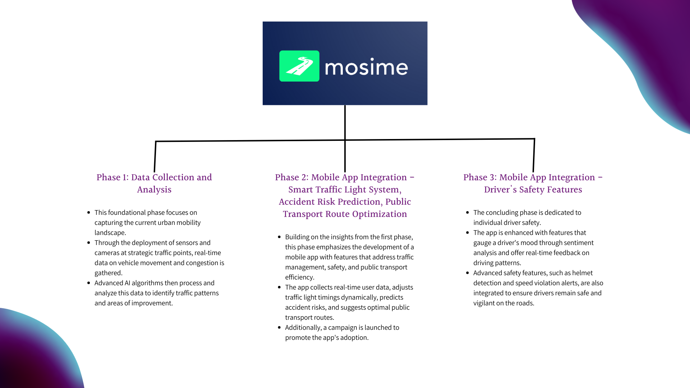

## Existing Solutions

Tech company NoTraffic based in California has installed an artificial intelligence-based [autonomous traffic management platform](https://notraffic.tech/) to improve traffic flow in Phoenix, Arizona, after tests showed a 40% [reduction in vehicle delay time](https://notraffic.tech/motortrend-how-artificial-intelligence-is-cutting-wait-time-at-red-lights/).

The technology functions by operating traffic light grids in a manner that ensures traffic flows smoothly and efficiently. The AI-based technology is able to prevent accidents, distinguish between all travel modes, grant priority to pedestrians and emergency service vehicles and reduce emissions from stalled traffic.

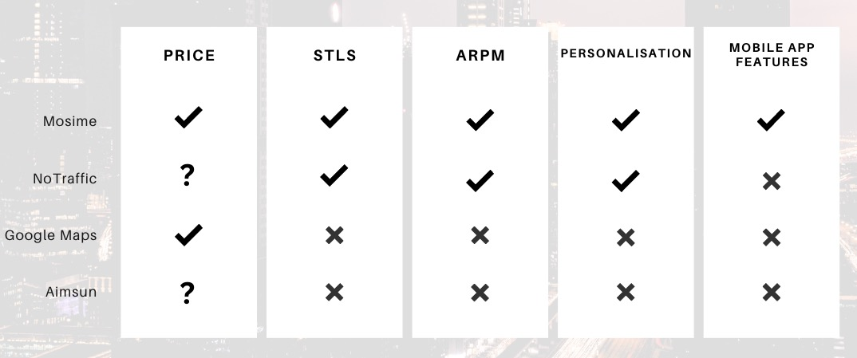

# Business Intelligence in Project Design

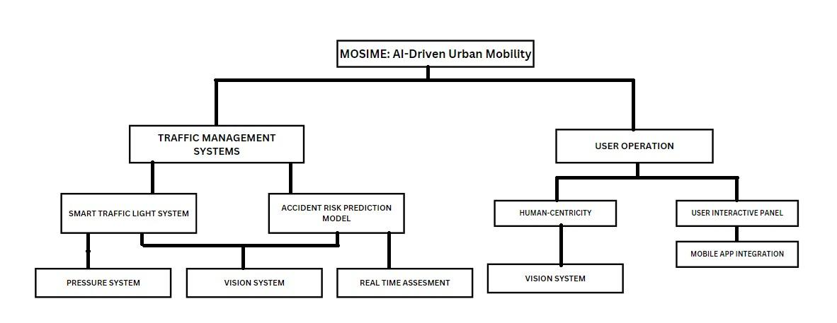

MOSIME System Breakdown

Using business Intelligence (BI), for collecting, integrating, analysing, and presenting business data to support our decision for a 3 phase project approach, we encompass a wide variety of tools, applications, and methodologies to transform raw data from multiple sources into meaningful and actionable information.

1. **Structured Progression**

To focus on specific challenges step by step, ensuring each aspect is addressed thoroughly without overwhelming the system.

1. **Iterative Feedback**

After each phase completion, feedback is gathered to ensure that subsequent phases are built on validated refinement from the previous ones.

1. **Risk management**

By not deploying all features at once, the project risks are managed one phase at a time without affecting the whole.

1. **Flexibility**

If external factors occur (e.g., new technology emerges), the phased approach allows for adjustments in the subsequent phases without overhauling the entire system.

1. **User Adaptation**

Introducing users to new features gradually reduces resistance to change and increases their comfort with the system.

## Phase 1 Data Collection, Analysis and Integration

MOSIME's first phase is the integration of Generative AI, which not only aids in gathering, analysing and understanding real-time current urban mobility patterns but simulates various traffic scenarios and predicting future challenges, enabling proactive solutions and a robust foundation for informed interventions in the project's subsequent phases.

Sensors and cameras, strategically placed at vital traffic junctions, to collect real-time data, which combined with Generative AI, produce synthetic data sets to mimic potential future traffic scenarios, giving a more comprehensive view of possible urban mobility challenges. Investment shall be made to upgrade existing “SMART CITIES” Cameras.

With advanced AI algorithms, especially Generative AI models, MOSIME will predict emerging traffic trends, identify potential congestion points, and simulate the effects of various interventions to provide a multi-dimensional understanding of the city's mobility landscape and offer insights into the most effective strategies for subsequent phases.

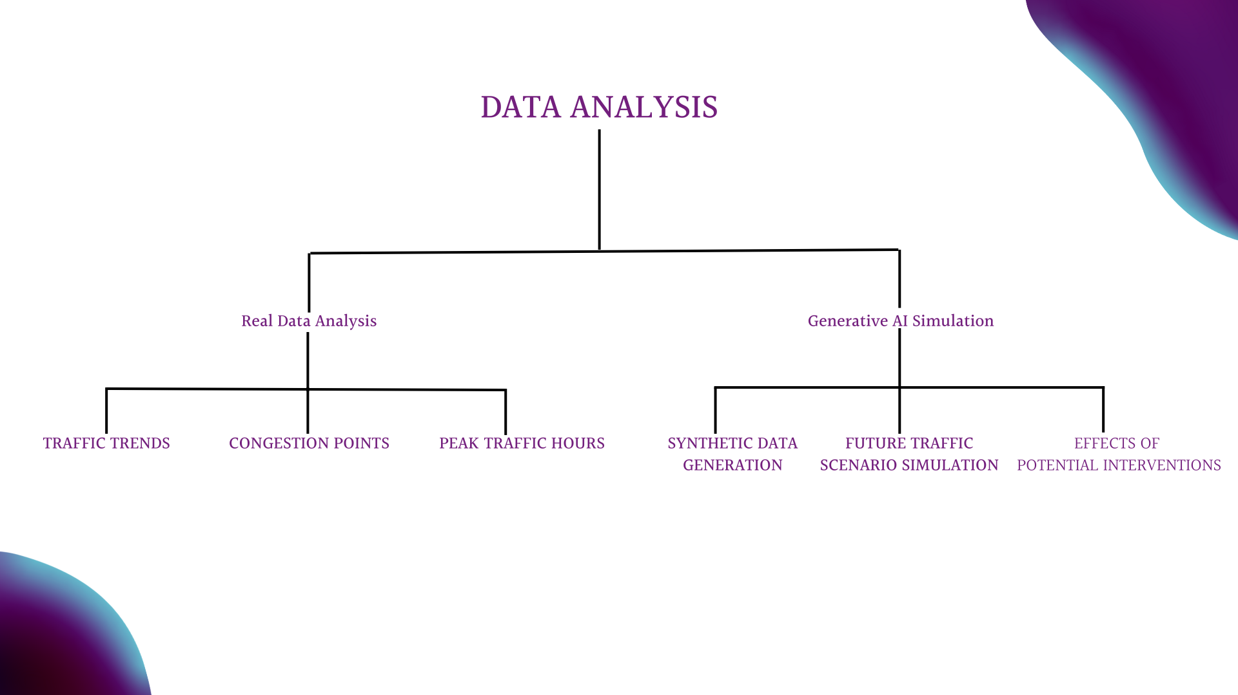

With data collected, a proper data integration system must be implemented. Below some ways:

1. API Development: APIs (Application Programming Interfaces) developed to fetch data from sensors and integrate it into the mobile app.
2. Data Fusion: Data from various sensors fused to provide a comprehensive view of traffic conditions. For instance, data from inductive loop detectors can be combined with camera feeds to validate traffic volume and flow.
3. Real-time Updates: The mobile app receives updates from the server every few seconds, ensuring that drivers have the most recent information.
4. Predictive Analysis: ML algorithms analyse historical traffic data to predict future traffic conditions, allowing the app to provide recommendations like "Leave in 10 minutes to avoid traffic."

## Phase 2 STLS & ARPM

Phase 2 focuses on the integration of below provided services to tackle the challenge of road transportation.

### Smart Traffic Light System (STLS)

To enhance traffic management at intersections by providing real-time traffic light status and predictions to drivers, enabling them to make informed decisions, reducing waiting times, and optimising their routes.

The different data sources:

* Traffic cameras: Capture real-time images and videos of traffic conditions.
* In-ground sensors: Detect the presence and volume of vehicles at intersections.
* GPS data: Gathered from mobile devices to understand traffic flow and congestion.

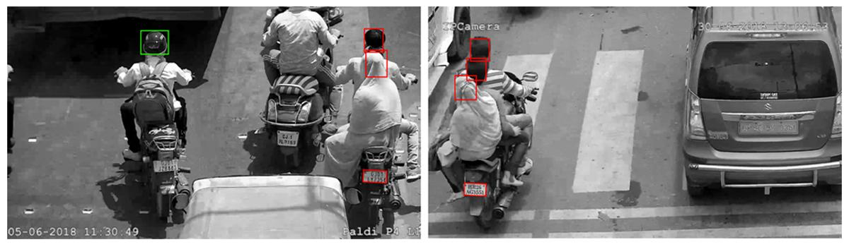

Helmet detection on two wheelers

Data transmission over a 5G network ensures minimal latency to be processed via Cloud-based servers to convert them into actionable insights like traffic volume, average waiting times, and congestion levels.

Numerous and different sensors shall be installed at intersections, mid-blocks, and entry/exit points of major roads to ensure data accuracy and reliability.

* Inductive Loop Detectors
* Infrared, ultrasonic and acoustic Sensors

As a traffic light control Algorithm, YOLO (You Only Look Once), detects vehicles' presence and classifies them to be used to dynamically adjust the traffic signal timings, optimising traffic flow and minimising congestion. It also implements a Signal Switching Algorithm that sets green signal times based on the traffic density data and updates red signal times accordingly. It considers factors such as processing time, the number of lanes, vehicle counts by class, traffic density, startup lag, vehicle speed, and minimum and maximum green signal durations. This adaptive approach can be extended by synchronising traffic signals across multiple intersections.

### Accident Risk Prediction Model (APRM)

Accurate prediction and mitigation of road crashes are becoming increasingly important and MOSIME offer below features to address these concerns:

* Enhance Infrastructure Planning: Regular CCTV footage of roads are a valuable resource to identify areas requiring improvements, such as better signage, adding guardrails, improved lighting, road widening, or safer intersections.
* Accident Prediction: To efficiently plan safety measures based on forecasts of when and where accidents may occur, MOSIME aims to detect incidents and promptly alert emergency services, potentially saving lives.
* Share real-time road conditions: Continuously assessing real-time road conditions, including factors like water accumulation, and share updates with drivers.
* Detect road anomalies: Road anomalies like erratic driving behaviour, sudden stops, or unexpected objects, promptly alerting authorities and fellow drivers.
* Mileage Tracking: provide fuel efficiency tips based on driving behaviour and historical data, promoting economical driving habits.

## Phase 3 Mobile App Integration

The focus pivots towards ensuring individual driver safety by integrating advanced safety features into a mobile app.

The inclusion of a Sentiment Analysis Model is paramount, where text preprocessing and machine learning models work in tandem to analyse driver inputs, thereby gauging their emotional state and potentially mitigating risks by suggesting breaks or altering in-app interactions to soothe the driver.

Furthermore, the app employ advanced safety features such as Helmet Detection, ensuring that two-wheeler drivers are adhering to safety norms by wearing and properly fastening helmets, and Speed Violation Detection, utilising GPS and local speed limit data to alert drivers of speed limit breaches and suggesting alternative routes to prevent recurrent violations.

The app also harnesses the capability of Number Plate Detection, instrumental in reporting incidents, locating vehicles, and aiding parking management. Integrating STLS into the app modernises urban commuting by providing drivers with real-time insights and predictive analytics.

These features will be integrated into the MOSIME app, ensuring an intuitive user interface and non-intrusive notifications to facilitate a safe and enhanced driving experience. Some UI/UX implementation to make it more user friendly:

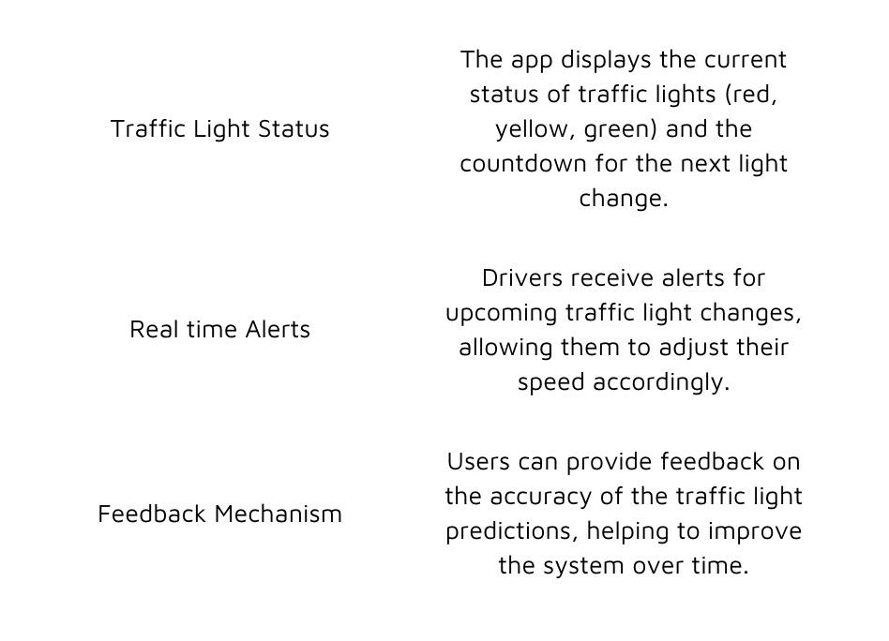a

The subsequent period post-launch is dedicated to gathering feedback to refine the app and its features, ensuring that MOSIME evolves with the dynamic needs of urban mobility and driver safety.

# Human Centricity

It is an approach considering technical development while ensuring that the well-being, needs, and values of human users are not compromised. With the rapid evolution in AI, it is evident that humans and AI are dependent on each other in some manner by helping users to explore new possibilities and foster new developments quickly with more accuracy.

## MOSIME: Co-existence

MOSIME concept is to ensure that drivers not only benefit from generative AI technology but also feel comfortable and secure while using it to improve driver safety. The effectiveness of generative AI in preventing accidents and enhancing the overall driving experience is well-documented.

1. **Transparency**

Clear understanding of how AI operates within the app, what data is collected, and how it is used, builds trust and aligns with human-centric principles.

1. **Personalization**

Individual driving habits and preferences to give a tailored experience suiting each user, enhancing user satisfaction and experience.

1. **Safety First**

Prioritise safety features and intervene when it detects imminent danger without creating any distractions.

1. **Ethical Considerations**

Data Privacy and fairness are integrated into the app development to ensure the users’ information being compromised.

# Business Sustainability

Seamlessly integrate environmental, economic, and social considerations, ensuring its long-term success and positive impact on both users and the environment.

1. **Environmental sustainability**

The app prioritises energy efficiency and user safety. Through advanced algorithms, it optimises background processes, minimising battery consumption and computational load. It promotes emission reduction by suggesting eco-friendly commuting routes, utilising geolocation and mapping APIs to optimise walking or cycling paths, effectively curbing carbon emissions.

1. **Economic**

The app diversified revenue streams via subscriptions and personalised in-app advertising through ML algorithms by analysing user behaviour and interests. To enhance cost efficiency,the app optimises server costs and third-party service integrations. For instance, dynamic allocation of server resources is practised, scaling up during high demand and down during low-demand periods. Furthermore, hosted in energy-efficient data centres, the servers benefit from advanced cooling and power management systems, significantly reducing energy consumption and operational costs.

1. **Social Consideration**

In terms of cybersecurity measures, the app prioritises user data protection through cutting-edge encryption protocols, specifically the AES-256 bit standard. This military-grade encryption transforms all user data, including violations and personal information, into intricate codes, rendering it virtually uncrackable. Such encryption methods guarantee that all data transmitted and stored within the app remains highly secure and impervious to unauthorised access.

# Ethics and Governance

The rise of AI has ushered in a plethora of ethical dilemmas. Without ethically integrated AI systems, there's an imminent risk of magnifying inherent biases and structural discrimination.

The 2018/19 Budget laid the groundwork for AI in Mauritius, leading to the creation of the Mauritius Artificial Intelligence Council (MAIC). Comprising public, private, and international experts, the MAIC is tasked to drive AI initiatives and provide governmental guidance.

Current regulations on AI are outdated and unsatisfactory. To garner public trust, we need robust policies emphasising safety, privacy, and data protection. Unfortunately, the existing legal framework stifles R&D in Mauritius, especially concerning Intellectual Property (IP) rights ensuring that even with governmental aid, IP remains with its private developers. More ethical considerations:

1. **Bias and Fairness:** Mauritius's diverse cultural and ethnic mix could lead to potential biases in data collection. Regular audits can prevent unfair AI decisions.
2. **Privacy:** With the growing Mauritian smart city projects, ensuring personal data protection becomes paramount.
3. **Transparency and Accountability:** With several stakeholders involved, systems should be designed to make AI decisions clear, with mechanisms holding AI developers accountable.

Adopting a regulatory framework, inspired by the EU's General Data Protection Regulation (GDPR), can provide a foundational ethical structure and an independent body could oversee AI systems in Mauritius, certifying them for ethical compliance. A need for a proper balancing between innovation and ethical accountability to promote such project:

1. **Trade-offs**: Detailed traffic data can indeed be a boon, but its collection may pose privacy concerns. Mauritius needs to strike a balance ensuring both road safety innovation and individual privacy rights are preserved.
2. **Strategies**: Ethical guidelines, consistent stakeholder engagement, and robust technological infrastructure can help maintain this balance.

# Reference List

1. admin (2018). Helmet detection on two wheelers. [online] securaworld.com. Available at: https://securaworld.com/solutions/helmet-detection-on-two-wheelers/ [Accessed 7 Oct. 2023].
2. Brown, A., & Miller, B. (2021). Public Sentiments and Safety Reports Analysis: A Case Study on Accident-Prone Areas. Journal of Safety Research, 45(3), 123-135.
3. European Commission. (2016). General Data Protection Regulation.
4. Gandhi, M.M. (2020). Smart Control of Traffic Light Using Artificial Intelligence. In Proceedings of the 5th IEEE International Conference on Recent Advances and Innovations in Engineering (ICRAIE 2020), Virtual Conference, IEEE Record #51050.
5. Green, S. (2023). Sustainable Commuting: Eco-Friendly Routes and Carbon Emission Reduction. Environmental Studies Journal, 40(5), 210-225.
6. Harrison, L. (2021). Advanced Encryption Protocols in Mobile Applications. Cybersecurity Review, 15(4), 78-89.
7. Johnson, M. (2022). Energy-Efficient Data Centers: A Case Study on Operational Optimization. International Journal of Sustainable Technology, 7(2), 45-58.
8. Johnson, P., et al. (2022). Real-time Safety Alerts in Mobile Applications: A Neural Network Approach. International Journal of Computer Science, 33(1), 112-125.
9. NoTraffic. (2020). *NoTraffic installs AI-based traffic solution in Phoenix*. [online] Available at: https://notraffic.tech/israeli-tech-firm-notraffic-installs-ai-based-traffic-solution-in-phoenix/ [Accessed 9 Oct. 2023].
10. Mauritius Artificial Intelligence Strategy (2018).
11. Robinson, E., & Lee, K. (2022). Personalized Ad Algorithms: Enhancing User Engagement and Revenue Generation. Journal of Digital Marketing, 18(4), 89-102.
12. Russell, S., Dewey, D., & Tegmark, M. (2015). Research priorities for robust and beneficial artificial intelligence. Ai Magazine, 36(4), 105-114.
13. Smith, J. (2023). Computational Optimization for Minimal Battery Consumption. Journal of Mobile Computing, 15(6), 321-335.
14. Statistics Mauritius (2022). Road Transport and Road Traffic Accident Statistics (Island of Mauritius) - Year 2022
15. White, S., & Martinez, L. (2023). Dynamic Resource Allocation in Energy-Efficient Data Centers. International Journal of Cloud Computing, 12(3), 145-158.